**Reverse proxy in Nginx**

In this documentation we will install node.js and we will make one node.js app and after that we will set up nginx as a reverse proxy.

**Step 1: Install node.js**

We should always use NVM (node version manager) for installing node.js because it allows us to install and maintain the different versions of node js.

Other commands will only install the latest version but using this we can install whichever version that we want.

Download the script for nvm

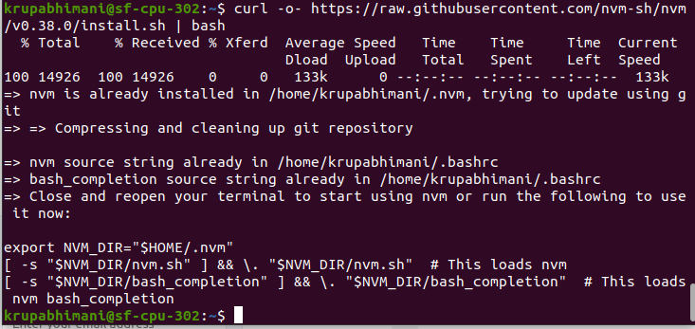

Using the below command you can install the node.js using nvm by specifying the specific version

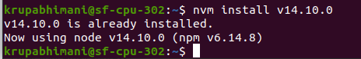

You can check the version of node by using this command.

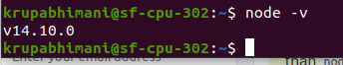

Npm is package manager in node.js you can verify that npm is installed or not using this command



To work npm packages you need to install this build-essential package

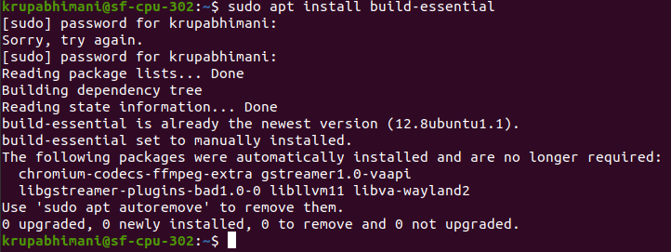

**Step 2: create simple node.js application**

Create one sample application called hello.js

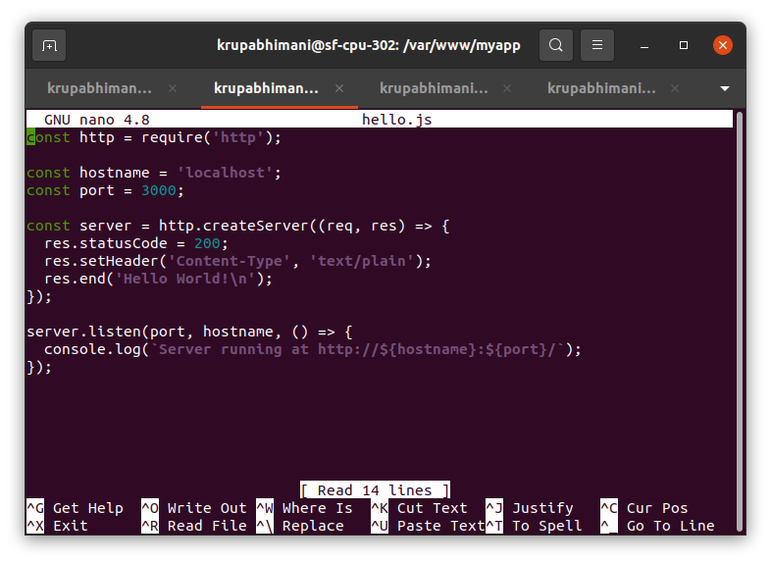

Test your application



Type localhost:3000 in browser to see the app running

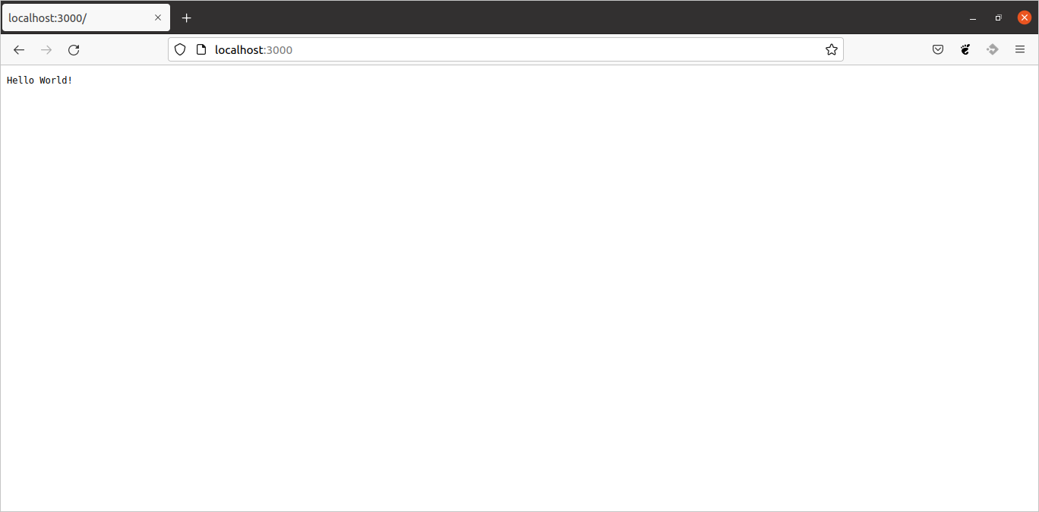

**Step 3: Installing PM2**

PM2 is process manager in node.js application and makes it possible to run in background as a service.

Use npm to install PM2

-g is for globally

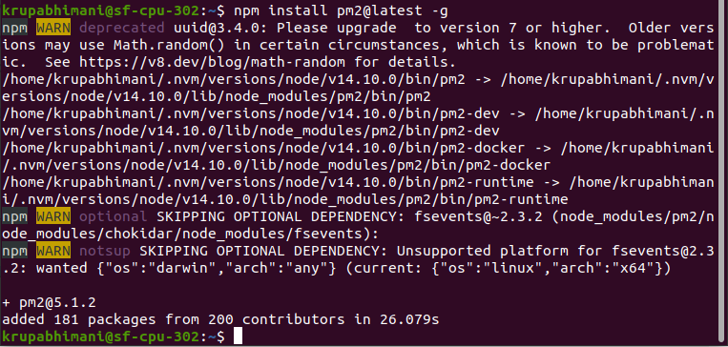

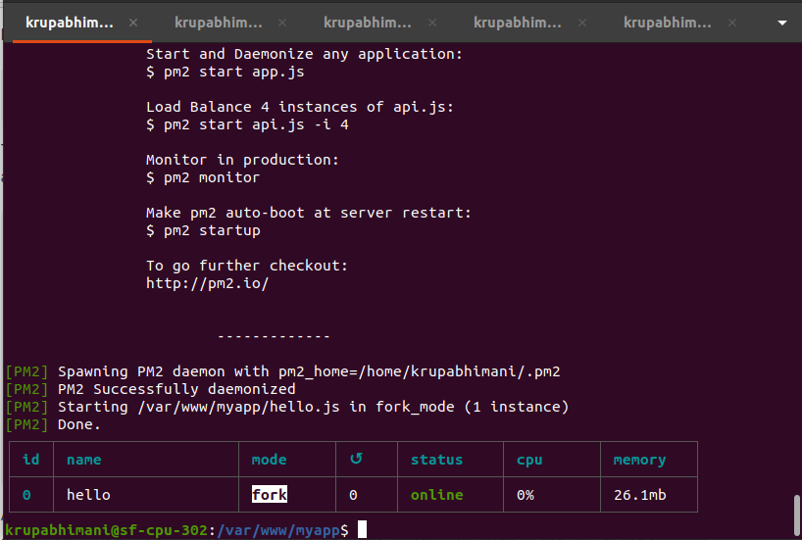

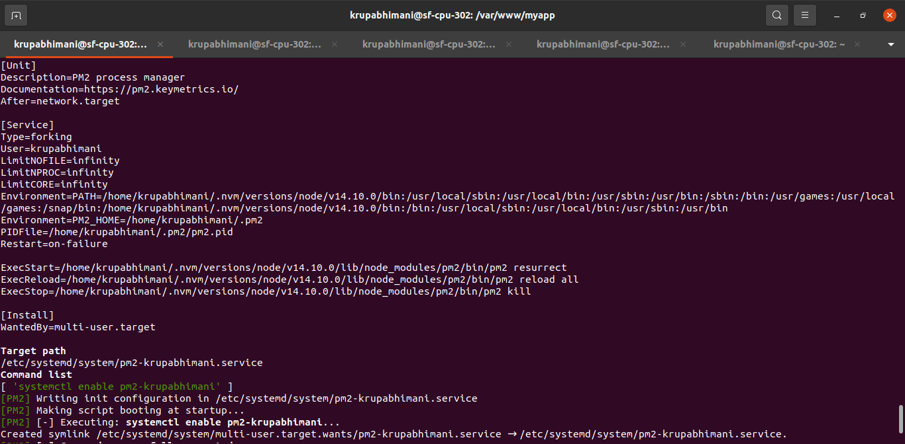

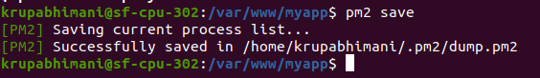

**Step 4: set up reverse proxy for node.js app in nginx**

We will create a file in sites-available which will transfer the request which is coming on port 3000 to localhost.

Create file called node-app

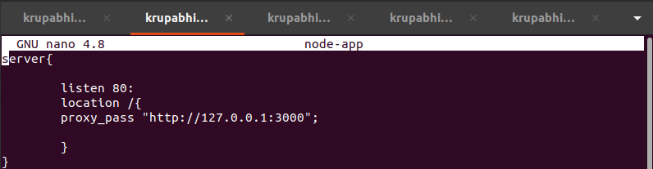

Create soft link for that



Check status and restart service

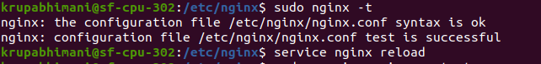

Type only localhost in the backend it will transfer the request to port 3000.

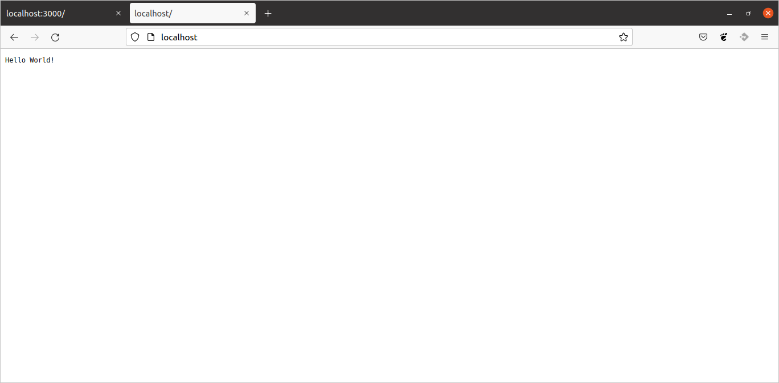

**For custom domain name:**

Add server name in server block

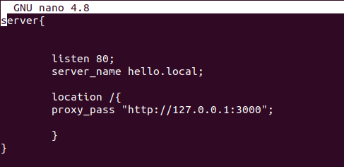

Add hostname in /etc/hosts file

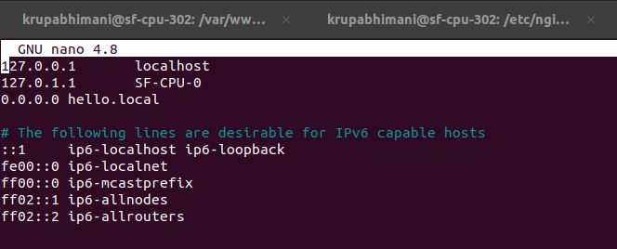

Now restart the server and type hello.local in browser

